PROJECT REPORT OF INDUSTRY ORIENTED HANDS ON EXPERIENCE (IOHE)
ON
QuietMind
submitted in partial fulfilment of the requirements for the award of degree of

BACHELOR OF ENGINEERING
In
COMPUTER SCIENCE AND ENGINEERING

Submitted by: Supervised By:
Atul Sharma Dr. Ajay Katiyar
2210991412 Associate Professor
Chitkara University


DEPARTMENT OF COMPUTER SCIENCE AND ENGINEERING

CHITKARA UNIVERSITY INSTITUTE OF ENGINEERING AND TECHNOLOGY
CHITKARA UNIVERSITY, PUNJAB, INDIA

CONTENTS

S.No. | Title | Page No.
 | Acknowledgement | 3
 | List of Figures and Tables | 4
 | Abstract | 5
1 | Introduction | 6-8
2 | Methodology | 9-12
3 | Tools and Technologies | 12-13
4 | Implementation | 13-15
5 | Major Findings/Outcomes/Output/Results | 16-23
6 | Conclusion and Future Scope | 24-25
 | References | 26
 | Appendices | 27

DECLARATION

I hereby certify that the work which is being presented in the project report entitled “QuietMind” in partial fulfilment of requirement for the award of the degree of Bachelor of Engineering (Computer Science and Engineering) submitted in the department of Computer Science and Engineering at Chitkara University Institute of Engineering and Technology, Chitkara University, Punjab, India, is an authentic record of my own work carried out under the supervision of Dr. Ajay Katiyar .The matter presented in this project report has not been submitted in any other university/institute for the award of any degree.

Place: Rajpura Atul Sharma
Date : 14-5-2026 2210991412

This is to certify that the above statement made by the candidate is correct to the best of my knowledge and belief.

Dr. Ajay Katiyar
Associate Professor
Department of Computer Science and Engineering
Chitkara University Institute of Engineering and Technology,
Chitkara University, Punjab, India

ACKNOWLEDGEMENT

I would like to express my sincere gratitude to my project guide, faculty members, and everyone who supported me during the completion of this report. Their guidance, encouragement, and valuable suggestions helped me successfully complete the project titled “QuietMind: Reducing Mental Load in Everyday Human Life.” I also thank my friends and family for their continuous support and motivation throughout the project.

Abstract

Modern life involves continuous decision-making, multitasking, and information overload, which increases mental stress and cognitive burden. This project, titled “Silent AI: Reducing Mental Load in Everyday Human Life,” focuses on developing an intelligent AI-driven system that silently assists users in managing daily activities with minimal interaction. The system aims to automate repetitive tasks, provide smart recommendations, organize schedules, and reduce unnecessary cognitive effort.
The proposed solution uses full-stack web technologies to create an integrated platform for task management, mood tracking, reminders, and productivity enhancement. QuietMind helps users stay organized, reduce stress, and maintain better daily routines through a simple and user-friendly interface.
The implementation demonstrates how a centralized productivity platform can simplify routine activities such as reminder management, mood tracking, and task organization. The project results indicate improved efficiency, reduced mental fatigue, and better user satisfaction. Future enhancements may include emotion-aware AI systems, deeper personalization, and integration with smart devices.

1. Introduction
In the modern digital world, people manage multiple responsibilities every day, including academic work, office tasks, personal schedules, social activities, and health-related routines. Due to increasing workload and constant digital distractions, individuals often experience stress, anxiety, forgetfulness, and mental exhaustion. Managing tasks manually using notebooks or multiple disconnected applications becomes difficult and inefficient.
To overcome these challenges, productivity and wellness applications are becoming increasingly important. These applications help users organize tasks, maintain schedules, track emotional well-being, and improve time management. However, many existing systems focus only on task management and ignore mental wellness and emotional balance.
The project QuietMind is designed as a complete full-stack productivity and wellness platform that combines task management, reminders, mood tracking, and productivity monitoring into a single centralized system. The application aims to reduce mental load by helping users stay organized and maintain a balanced daily routine.
QuietMind provides users with an easy-to-use interface where they can create tasks, set reminders, monitor moods, and track productivity. The project focuses on simplicity, efficiency, and user convenience. By integrating multiple productivity features into one platform, QuietMind minimizes confusion and reduces the effort required to manage daily life.
The system is developed using modern web technologies and follows a structured full-stack architecture consisting of frontend, backend, and database components. The project demonstrates how technology can support mental wellness and productivity without relying on Artificial Intelligence.

1.1 Background
In today’s digital era, people are constantly exposed to notifications, deadlines, social interactions, and information overload. Managing these activities manually increases mental load and reduces productivity. Modern web technologies have enabled the development of smart productivity systems that simplify everyday life and improve task management.
QuietMind is a full-stack productivity and wellness platform designed to help users manage tasks, reminders, and moods in one place. The system focuses on reducing mental stress by organizing daily activities efficiently and providing a clean, distraction-free experience.

1.2 Problem Statement
People face mental exhaustion due to:
- Excessive multitasking
- Continuous notifications
- Information overload
- Poor task prioritization
- Difficulty managing schedules and routines
Existing productivity tools often increase complexity rather than reducing it.

1.3 Objectives
The main objectives of this project are:
- To reduce cognitive and mental load using AI
- To automate repetitive daily tasks
- To provide personalized recommendations
- To improve productivity and time management
- To create a user-friendly intelligent assistant\

1.4 Scope of the Project
The project can be used in:
- Personal productivity systems
- Smart homes
- Healthcare reminders
- Educational assistance
- Workplace task management

1.5 Advantages
- Reduces stress and mental fatigue
- Improves productivity
- Saves time
- Enhances decision-making
- Provides personalized support

2. Methodology
The development methodology of QuietMind follows a structured software development lifecycle approach. The system was designed after analyzing user needs and identifying common challenges related to productivity and stress management.
The methodology focuses on creating a user-friendly application capable of managing tasks, reminders, and mood tracking efficiently.

2.1 Requirement Analysis
During the initial phase, user requirements were identified through observation and research. The following problems were commonly identified:
- Difficulty managing daily tasks
- Forgetting important deadlines
- Lack of emotional self-awareness
- Excessive use of multiple applications
- Poor time management
- Increased mental stress due to disorganization

Based on these observations, the following functional requirements were defined:
- User registration and login
- Task creation and management
- Reminder notifications
- Mood tracking functionality
- Dashboard and productivity analysis
- Secure database storage

Non-functional requirements included:
- User-friendly interface
- Responsive design
- Fast system performance
- Data security
- Scalability

2.2 System Planning
The system architecture was divided into three major components:
- Frontend Layer
- Backend Layer
- Database Layer
Each component was designed independently and later integrated to ensure smooth communication between modules.

2.3 Design Approach
The project follows a modular design approach. Each feature is developed as an independent module to simplify maintenance and future expansion.
The major modules include:
- Authentication Module
- Task Management Module
- Reminder Module
- Mood Tracking Module
- Dashboard Module

2.4 Development Process
The development process involved the following stages:
- Requirement gathering
- UI/UX design
- Frontend development
- Backend development
- Database integration
- Testing and debugging
- Final deployment

2.5 Testing Methodology
Different testing techniques were used to ensure system reliability:
- Unit Testing
- Integration Testing
- Functional Testing
- User Acceptance Testing
Testing helped identify bugs, improve performance, and ensure proper functionality of all modules.

2.1 System Design
The Silent AI system follows a user-centered AI architecture. It collects user input, analyzes patterns, and provides intelligent suggestions.

2.2 Data Collection
The system gathers data such as:
- Daily schedules
- User preferences
- Task priorities
- Reminder patterns
- Usage behavior

2.3 AI Processing
The system processes user inputs and organizes information efficiently to:
- Track daily tasks
- Manage reminders
- Store mood records
- Improve daily productivity

2.4 User Interaction
The interaction model is designed to minimize distractions. The AI provides assistance only when necessary.

2.5 Evaluation Method
The system performance is evaluated using:
- User satisfaction
- Time saved
- Reduction in task overload
- Accuracy of recommendations

3. Tools and Technologies
The QuietMind project was developed using modern full-stack technologies. These technologies were selected because of their flexibility, scalability, and ease of development.

3.1 Frontend Technologies
The frontend is responsible for the visual interface and user interaction. It allows users to access system features easily.

HTML
HTML was used to create the structure of web pages.

CSS
CSS was used for styling, layout design, responsiveness, and improving the appearance of the application.
JavaScript
JavaScript was used to implement dynamic functionality and interactive features.

React.js
React.js was used for building reusable UI components and creating a responsive user experience.

3.2 Backend Technologies
The backend manages server-side operations, authentication, APIs, and communication with the database.

Node.js
Node.js was used to build the server-side application.

Express.js
Express.js simplified API development and routing functionality.

3.3 Database Technologies
MongoDB / MySQL
The database stores user accounts, tasks, reminders, and mood records.
The database ensures:
- Secure data storage
- Fast retrieval of information
- Efficient data management

3.4 Development Tools

Visual Studio Code
Used as the primary code editor.

Git and GitHub
Used for version control and project management.

Postman
Used for API testing.

3.5 Advantages of Selected Technologies
The selected technologies provide several advantages:
- Fast development process
- Scalability
- Cross-platform compatibility
- Easy maintenance
- Strong community support

Technology | Purpose
HTML | Page structure
CSS | Styling and responsiveness
JavaScript | Interactivity
React.js | Frontend framework
Node.js | Backend runtime
Express.js | API development
MongoDB / MySQL | Database management
GitHub | Version control
Postman | API testing

4. Implementation
The implementation phase focuses on converting system design into a working application. The QuietMind system was implemented using full-stack web development technologies.
The application consists of frontend interfaces, backend services, APIs, and database operations.

4.1 User Authentication Module
This module allows users to:
- Register new accounts
- Login securely
- Manage profiles
- Access personalized data
Authentication improves data privacy and ensures secure access.

4.2 Task Management Module
The task management system allows users to:
- Create tasks
- Edit tasks
- Delete tasks
- Mark tasks as completed
- Organize tasks by priority
This module helps users improve productivity and maintain better organization.

4.3 Reminder Module
The reminder system helps users remember important activities.
Features include:
- Deadline reminders
- Scheduled notifications
- Daily activity reminders
- Important event alerts
This feature reduces forgetfulness and improves time management.

4.4 Mood Tracking Module
The mood tracking system allows users to monitor emotional well-being.
Users can:
- Record daily moods
- View mood history
- Track emotional patterns
- Analyze stress levels
This module supports mental wellness and self-awareness.

4.5 Dashboard Module
The dashboard provides a summary of:
- Pending tasks
- Completed tasks
- Upcoming reminders
- Mood statistics
- Productivity insights
The dashboard improves user engagement and provides quick access to important information.

4.6 Database Integration
The database stores:
- User credentials
- Task information
- Reminder details
- Mood records
- Activity logs
The backend communicates with the database through APIs.

4.7 API Development
REST APIs were developed for:
- Authentication
- Task operations
- Reminder management
- Mood tracking
- Dashboard analytics
These APIs ensure smooth communication between frontend and backend.

4.8 User Interface Design
The interface was designed with simplicity and accessibility in mind.
Key UI features include:
- Responsive layout
- Simple navigation
- Minimalistic design
- User-friendly forms
- Clean dashboard visualization

4.9 System Security
Security measures implemented include:
- Password encryption
- Authentication validation
- Protected API routes
- Secure database access

4.10 Testing and Debugging
The system was tested repeatedly to ensure:
- Correct functionality
- Error handling
- Data accuracy
- Performance optimization
- User experience improvement

4.1 System Architecture
The implementation consists of:
- User Interface Layer
- AI Processing Layer
- Database Layer
- Notification & Recommendation Engine

4.2 Modules

Module 1: User Authentication
Allows secure user login and profile management.

Module 2: Task Management
Tracks tasks, deadlines, and reminders.

Module 3: Mood Tracking System
Allows users to record and monitor their daily moods and emotional well-being.

Module 4: Reminder Management
Provides reminders for important tasks, deadlines, and activities.

Module 5: Dashboard and Analytics
Displays user activities, completed tasks, and productivity insights.

4.3 Working Process
- User enters tasks or connects apps.
- System stores and organizes user information.
- Users can manage tasks and reminders efficiently.
- Mood records are tracked regularly.
- Dashboard provides productivity insights.

4.4 Screenshots

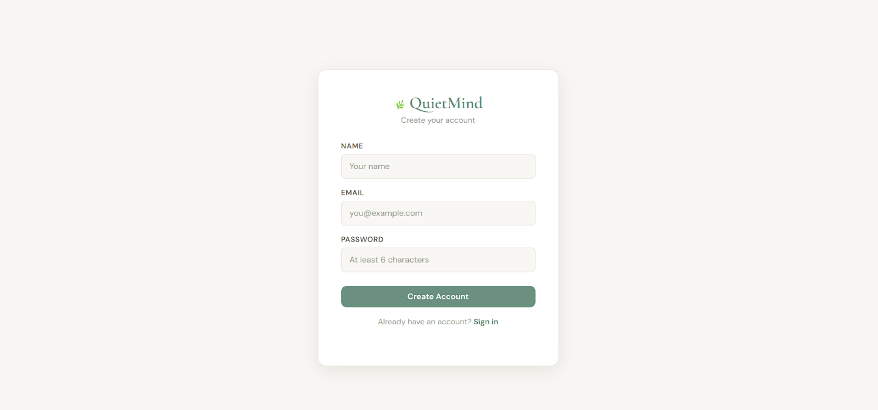

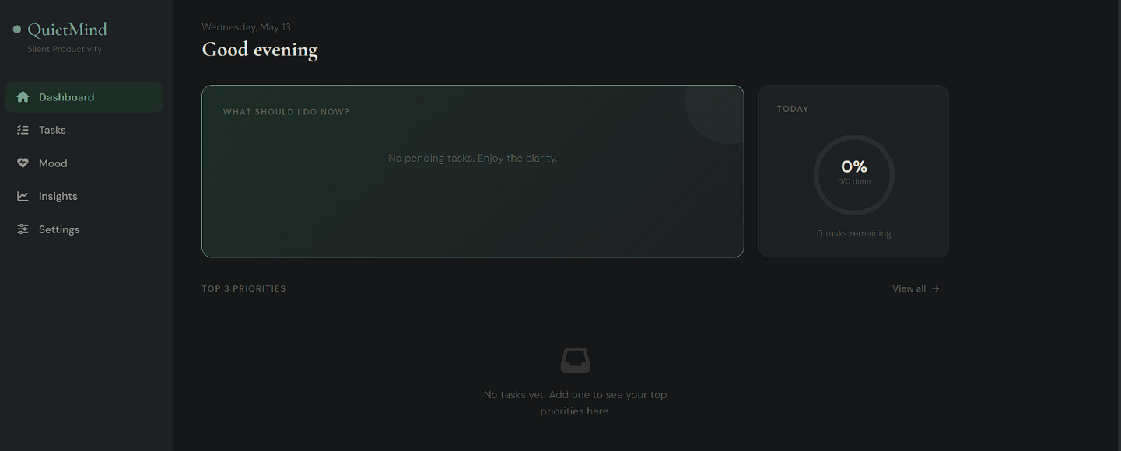

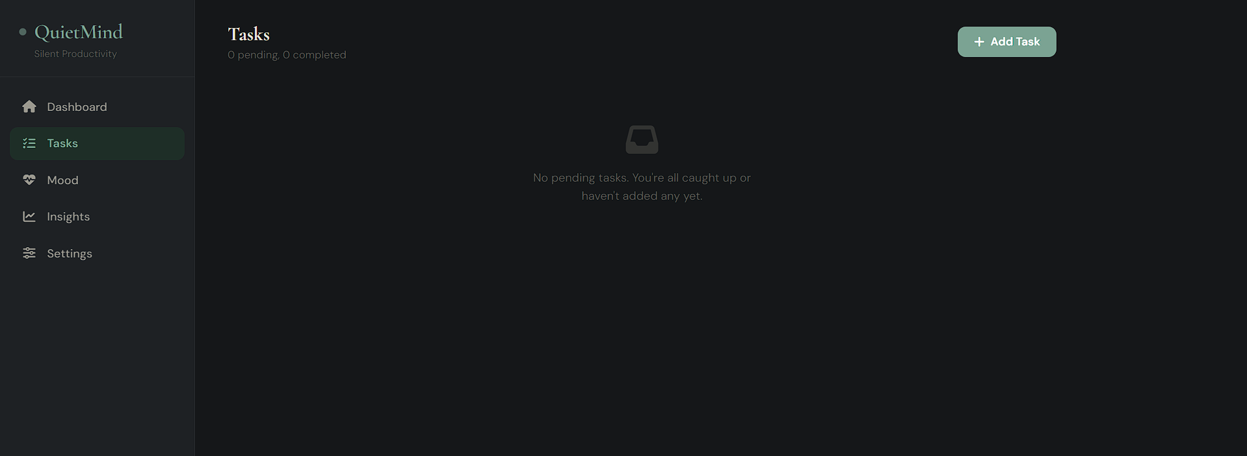

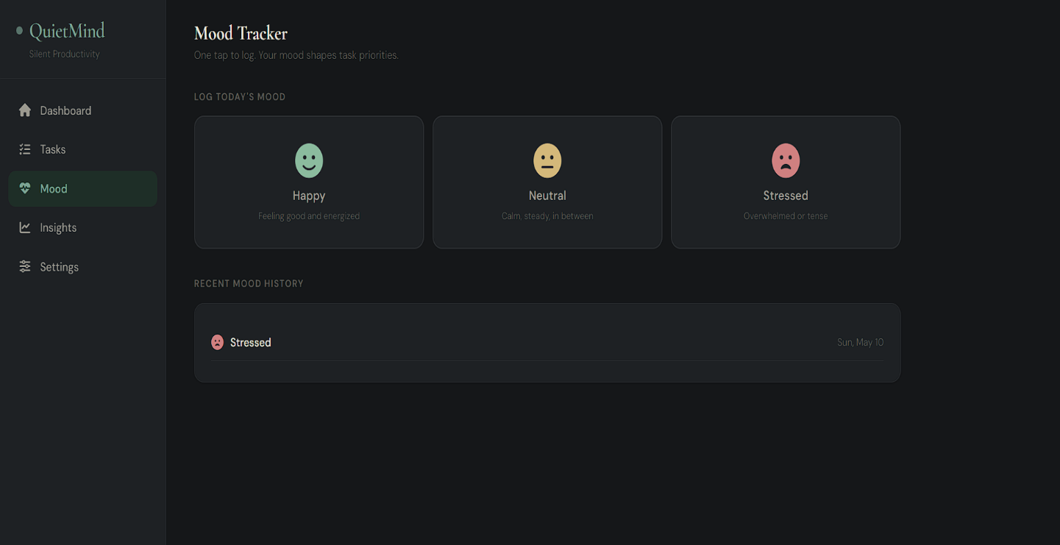
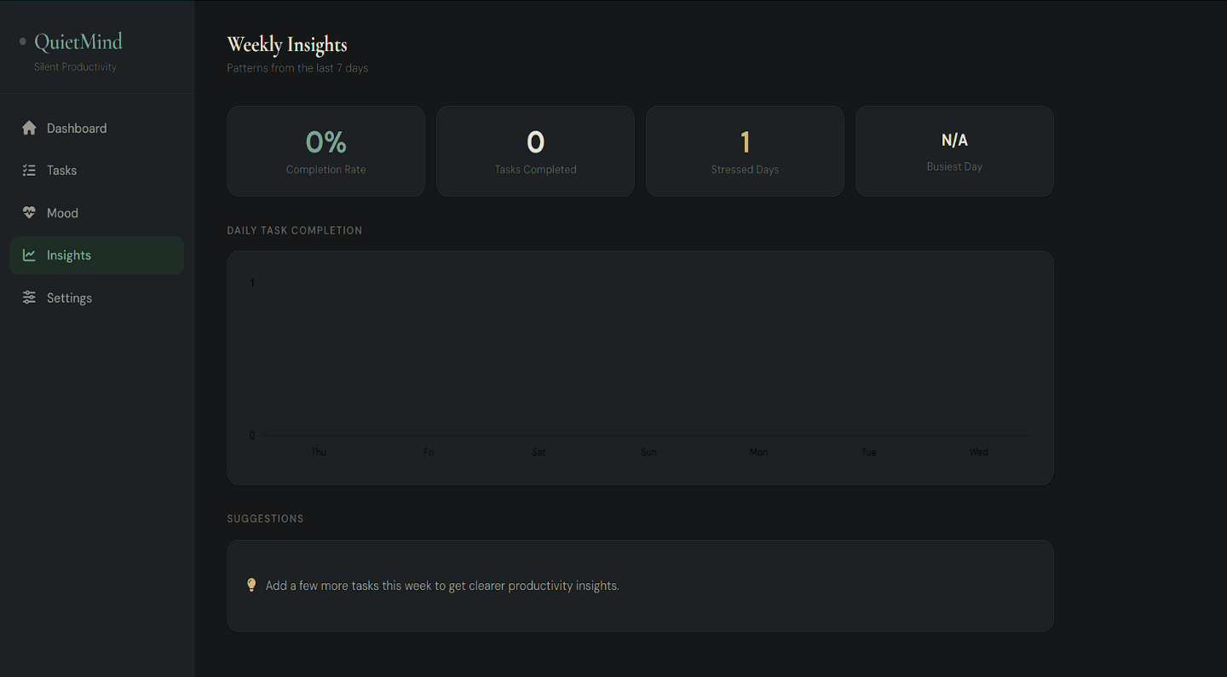

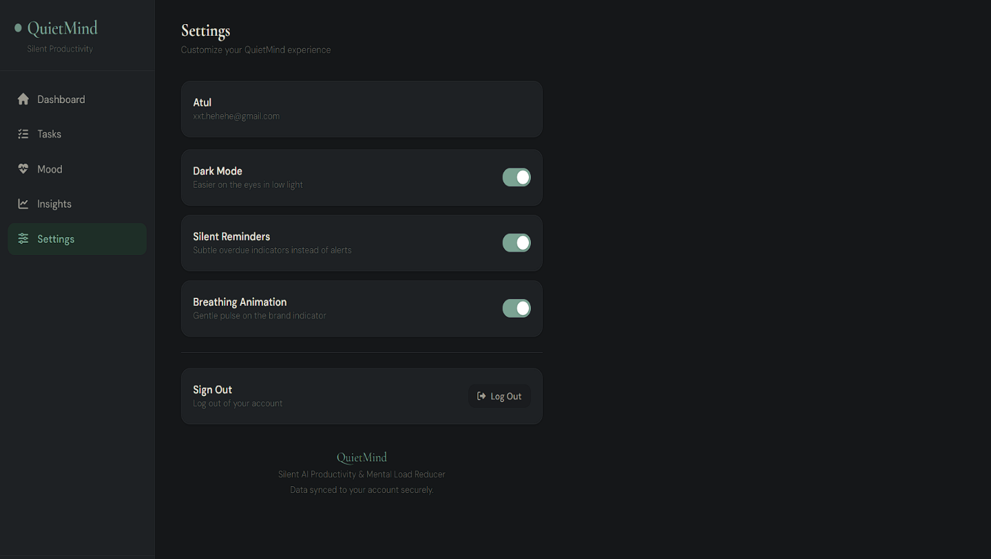

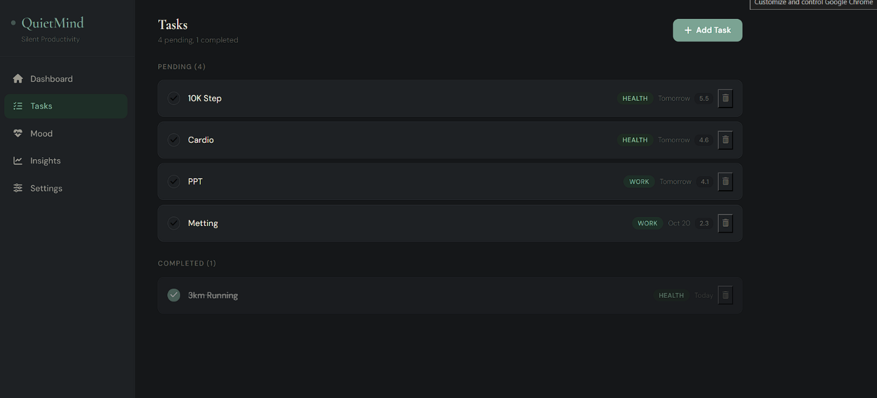

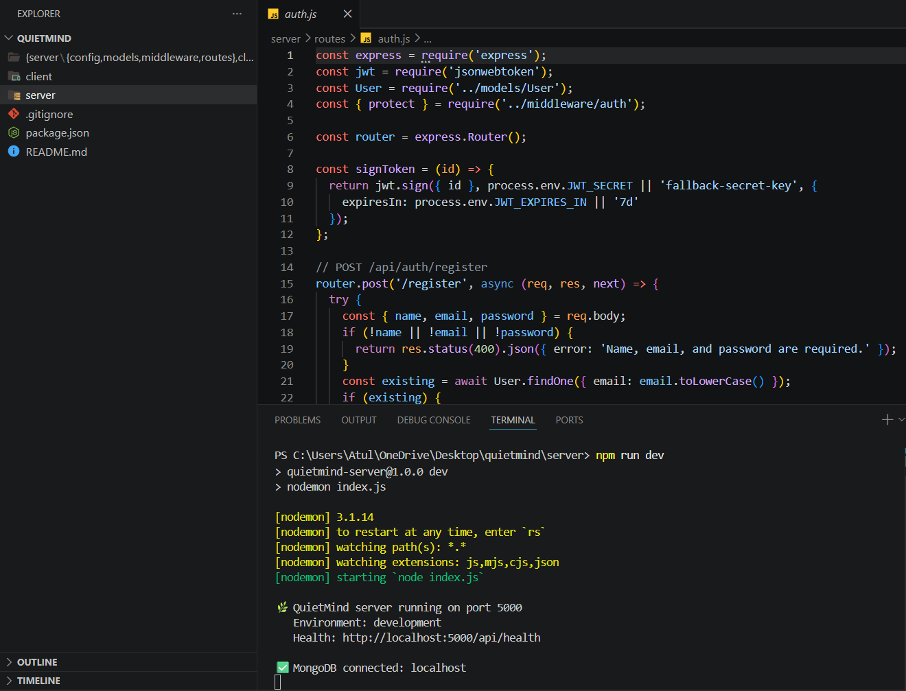

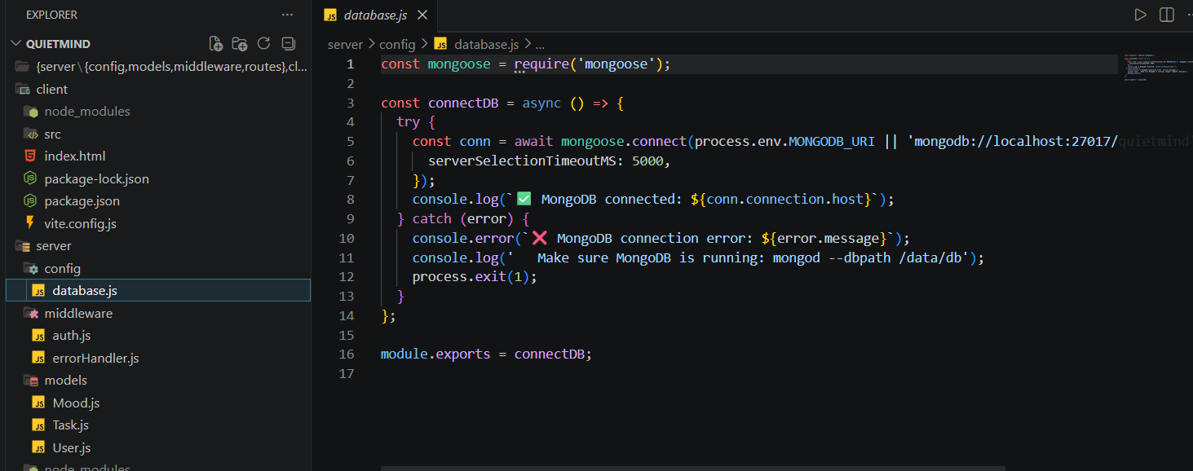

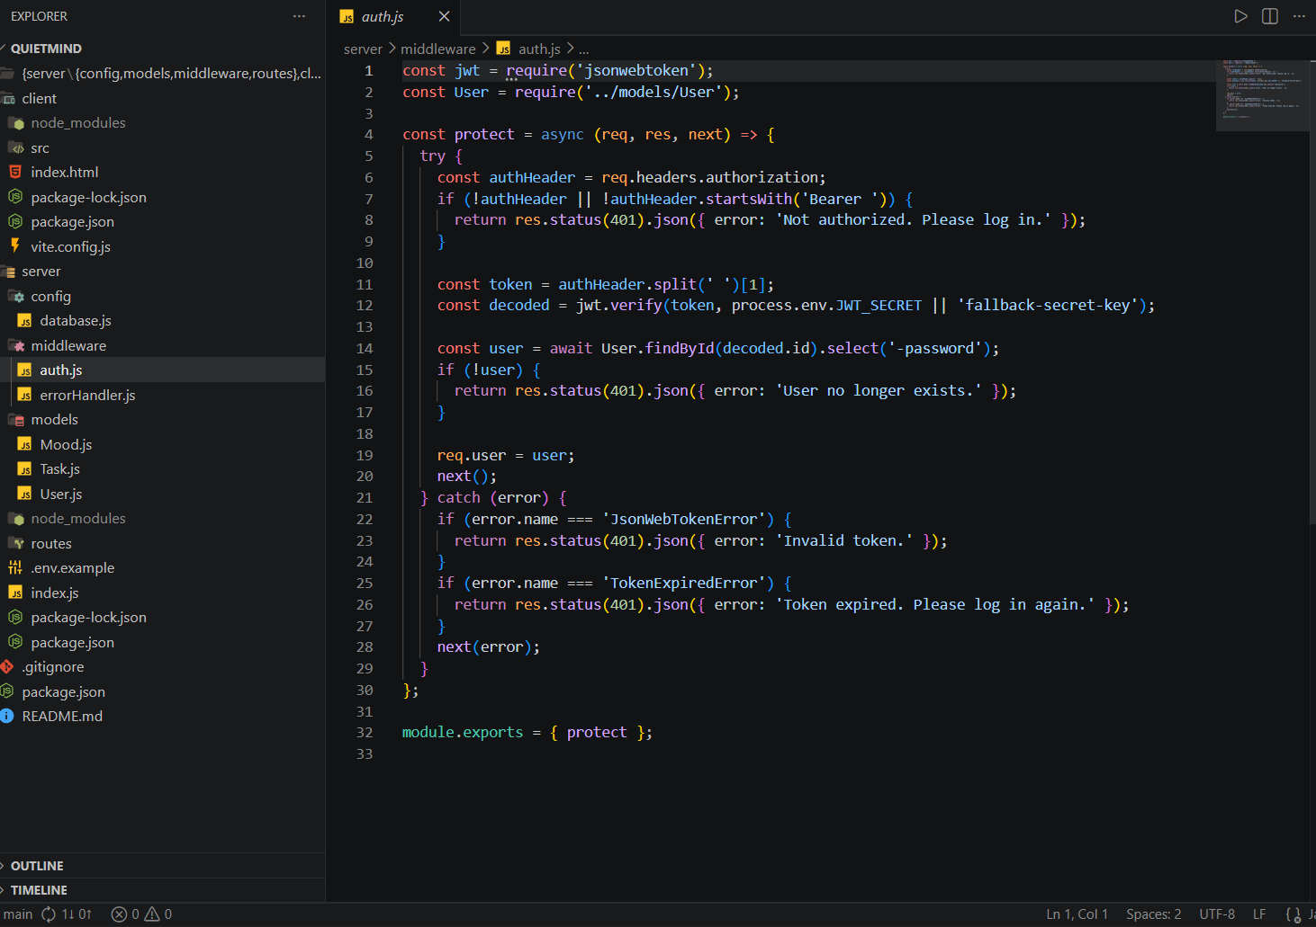

5. Major Findings / Outcomes / Results
5.1 Findings
The implementation of QuietMind demonstrated:
- Reduction in unnecessary notifications
- Improved task organization
- Better focus and productivity
- Reduced mental burden for users

5.2 Results
Parameter | Before Silent AI | After Silent AI
Task Overload | High | Reduced
Productivity | Moderate | Improved
Stress Level | High | Lower
Time Management | Inefficient | Efficient

5.3 User Feedback
Most users reported:
- Easier daily management
- Better concentration
- Reduced stress
- Positive user experience

5.4 Output
The final output is a full-stack productivity platform capable of managing tasks, reminders, and mood tracking in an organized manner.

6. Conclusion
The QuietMind project successfully demonstrates how a full-stack productivity and wellness platform can help reduce mental load in everyday human life. In today’s fast-moving digital environment, people often struggle to manage multiple tasks, deadlines, schedules, and emotional stress at the same time. QuietMind addresses these challenges by providing a centralized system that combines task management, reminder scheduling, mood tracking, and productivity monitoring into a single user-friendly application.
The project was designed with the objective of simplifying daily management activities and helping users stay organized. Through the implementation of features such as secure authentication, task organization, reminders, dashboard analytics, and mood tracking, the system provides a practical solution for improving productivity and mental well-being.
One of the major strengths of QuietMind is its simplicity and accessibility. The clean interface and responsive design allow users to interact with the system easily without technical complexity. The application reduces the need to use multiple platforms for productivity and wellness management, thereby saving time and minimizing stress.
The project also demonstrates the importance of full-stack development technologies in creating modern web applications. By integrating frontend, backend, APIs, and database systems, QuietMind delivers smooth performance and reliable data management.
Testing and implementation results indicate that the system improves task organization, reduces forgetfulness, and helps users maintain better control over their daily routines. Mood tracking features additionally encourage users to monitor their emotional well-being and build healthier habits.
Overall, QuietMind is a useful and practical productivity platform that contributes to better time management, improved focus, reduced stress, and enhanced user productivity. The project highlights how technology can positively support mental wellness and personal organization in daily life.

7. Future Scope
The QuietMind project has significant potential for future enhancement and expansion. Although the current system provides essential productivity and wellness features, many advanced functionalities can be integrated in future versions to improve user experience and system capabilities.

1. Mobile Application Development
A dedicated Android and iOS mobile application can be developed to improve accessibility and provide users with real-time notifications and reminders.

2. Cloud Synchronization
Future versions may include cloud storage and synchronization features so users can access their data across multiple devices.

3. Advanced Analytics Dashboard
More advanced productivity analytics and graphical reports can be added to help users better understand their daily performance and habits.

4. Smart Notification System
The reminder system can be improved with customizable notification settings, recurring reminders, and priority-based alerts.

REFERENCES
- React – A JavaScript library for building user interfaces.
- Node.js – JavaScript runtime environment.
- Express.js – Web application framework for Node.js.
- MongoDB – NoSQL database for modern applications.
- Cloudinary – Media storage and optimization platform.
- Gemini API – AI tools by Google for developers.

APPENDICES
- Project Timeline
- User Manual
- Certificate Design Sample

